Religious Education
- Parables - Stories of God’s People
- Creation Story

English
Reading
- UFLI (reading and spelling)
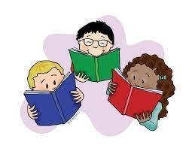
- Decoding strategies
- To build literal and inferential comprehension of an informative non-fiction text
- Features of Non-Fiction / Informative Texts
- Build vocabulary
- Grammar - identify sentences that expresses full thoughts and includes a ‘who’ and a ‘what’.

Writing
- Extend simple sentences to include when, who, what, and where
- Compound sentences
- Describe/compare/contrast events.
- Using correct punctuation
- Correct letter formation
- Knowledge of sounds to spell unfamiliar words
- Follow the Writing Process -
planning, drafting, revising, editing, conferencing, publishing

Speaking and Listening
- Speaking clearly in front of an audience
- Using topic-specific language to suit audience and purpose
- Using vocabulary about familiar topics
- Listening for specific purposes and information
- Share and extend ideas and respond
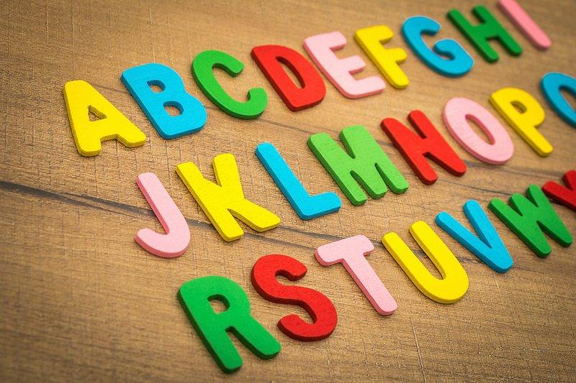

Mathematics
Number and Algebra

- Place Value
- Addition and Subtraction
Algebra
- Pattern
Measurement
- Length

Inquiry
Science is everywhere
- Weather and seasons
- Earth and Space
- Push - Pull
- Science inquiry skills to conduct experiments

Wellbeing
- Positive Behaviour for Learning
- Wellbeing
- Respectful Relationships
- Respecting Cultural Differences
- National Sorry Day

Digital Technology
- Using Digital systems safely

Physical Education
- develop skills in balance, throwing and jumping
- display sportsmanship and fair play during activities
- learn to play volleyball and cornhole
The Arts
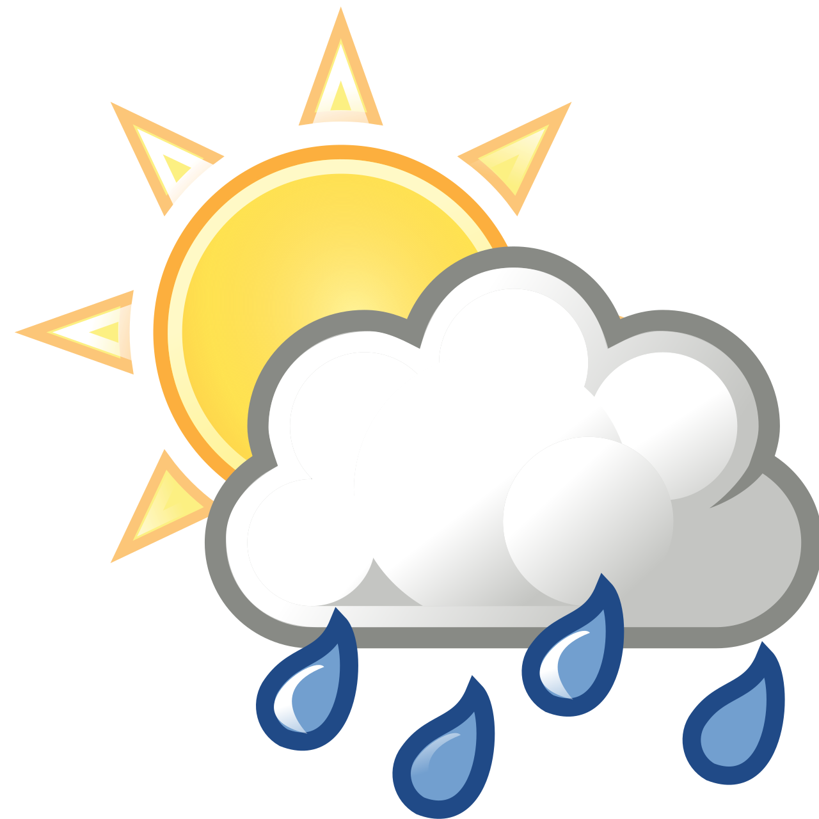
- Watercolour
- Famous world artists
Italian
My Space/ My Place
- Our spaces
  - School
  - Home
  - In the garden
  - Outer space/planets
- Weather
- Number revision

