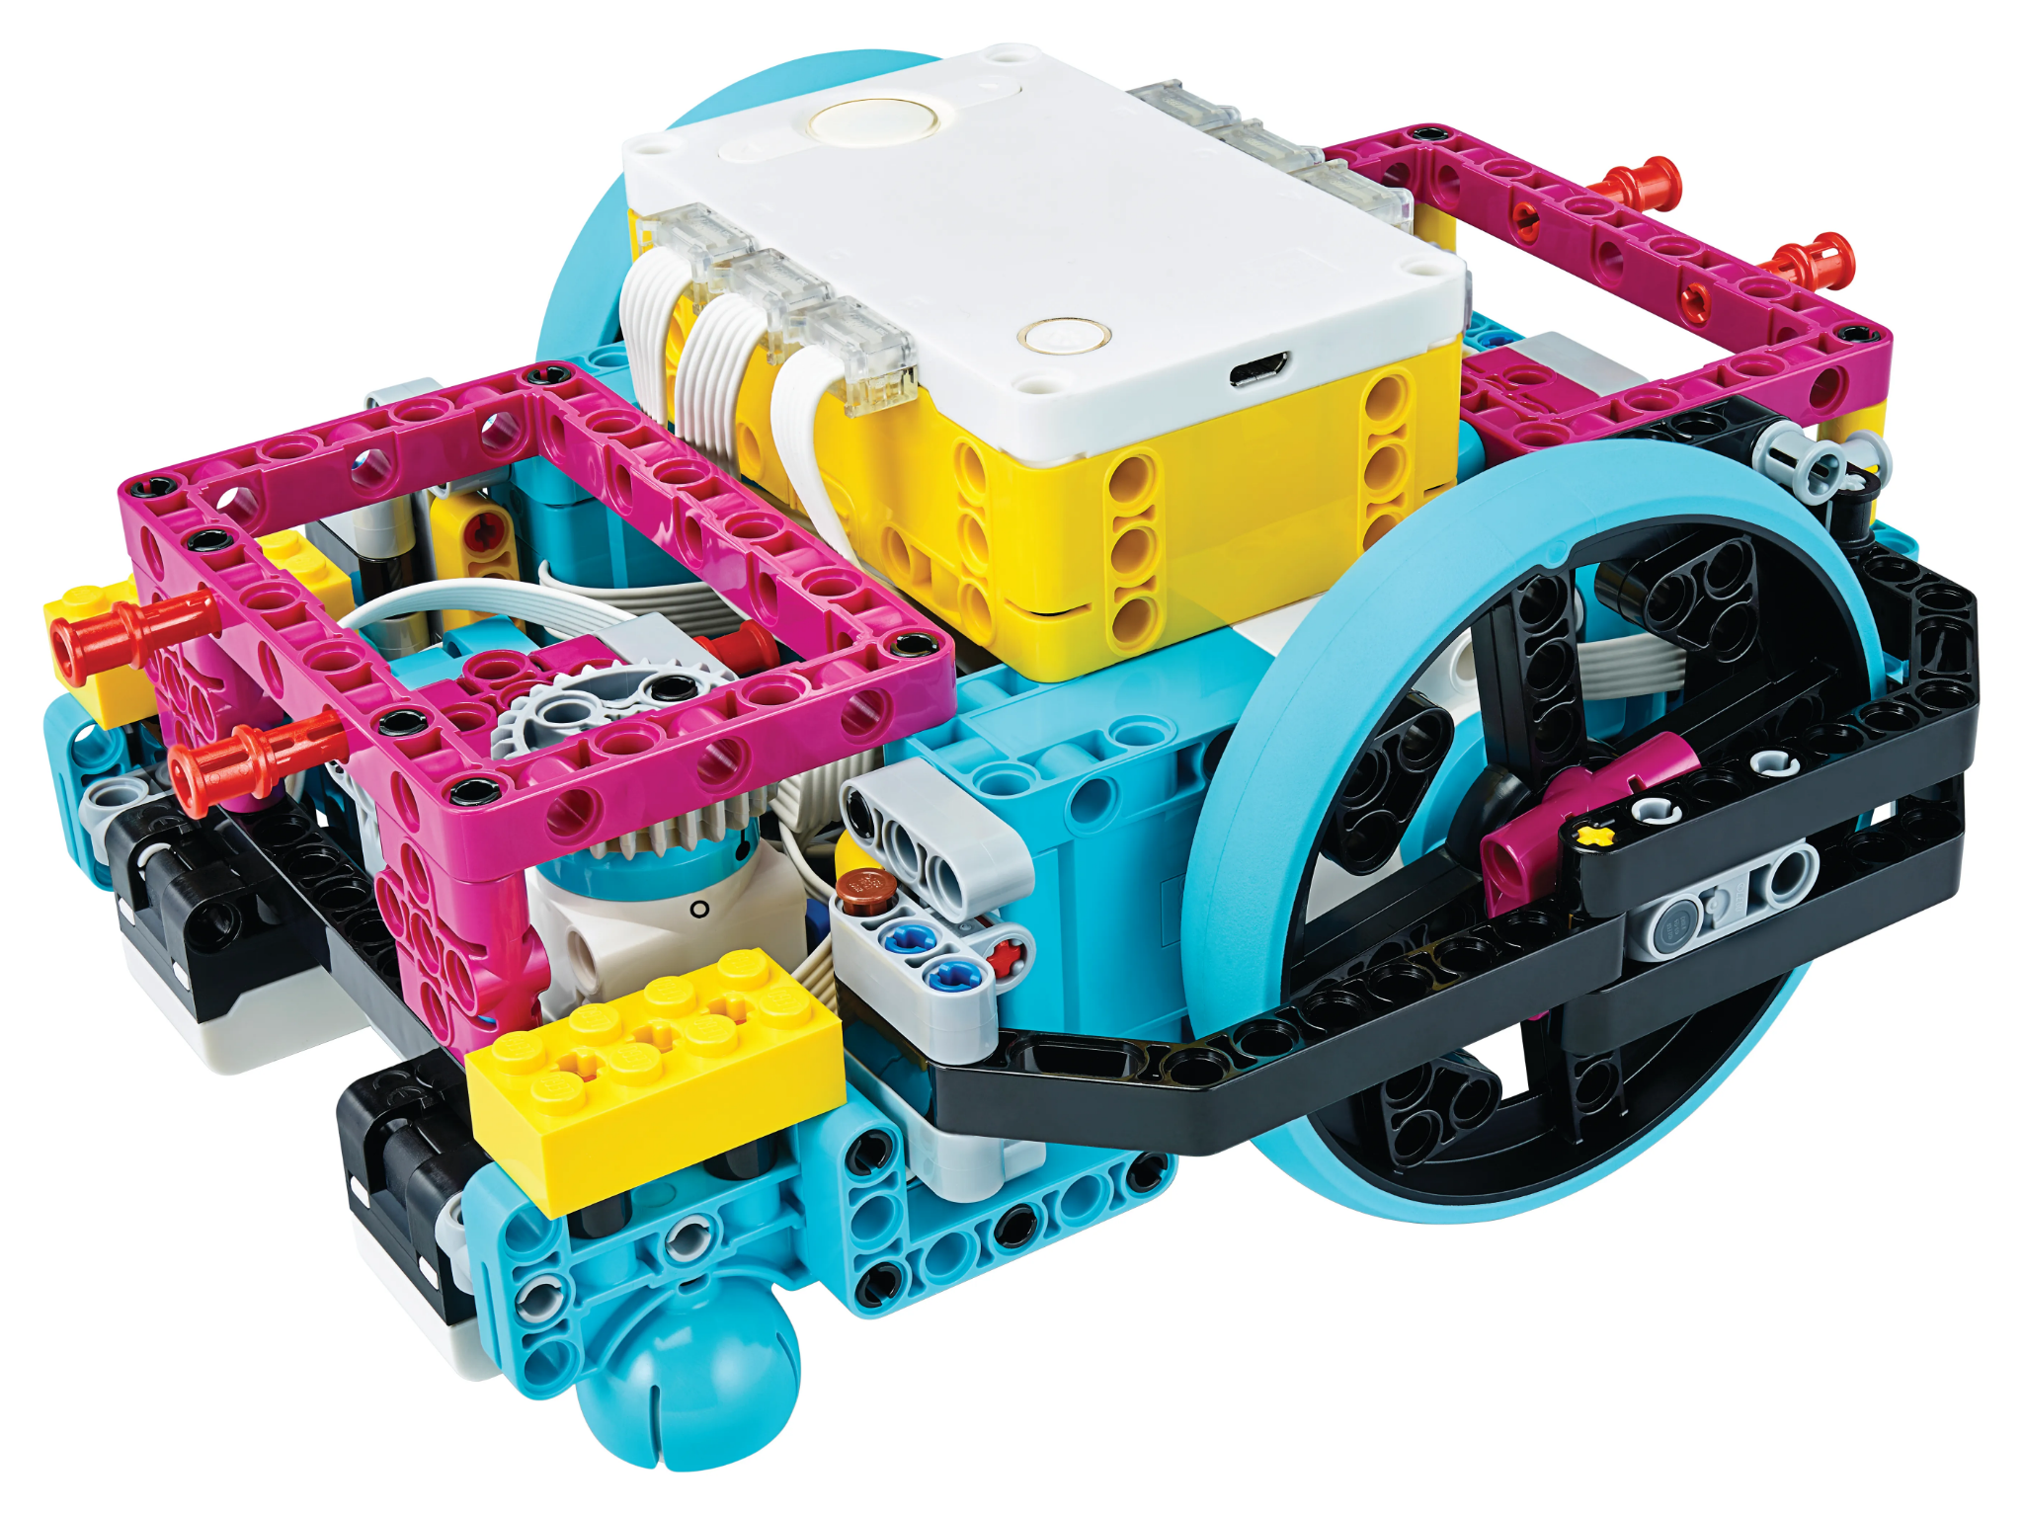

Year 5/6 – Term 2 Overview 2026

LITERACY

SPEAKING AND LISTENING

- Active listening by repeating & building on ideas
- Verbalising and connecting own ideas
- Interacting with the ideas of others
- Using precise vocabulary
- Delivering presentations
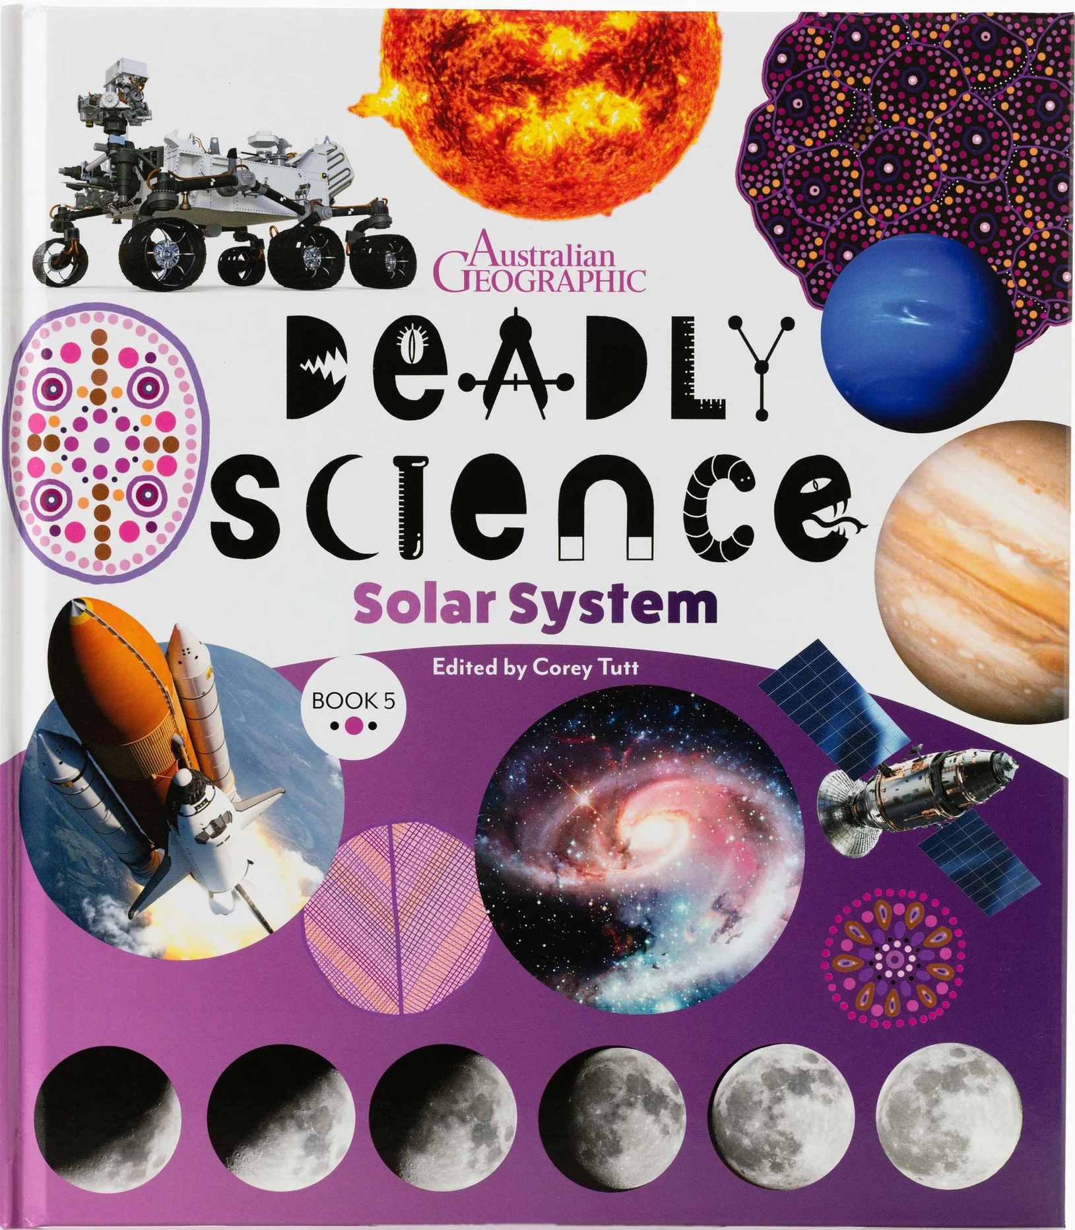
READING AND WRITING

- Novel Study - Deadly Science
- Explanation Text
- Novel Study - Once
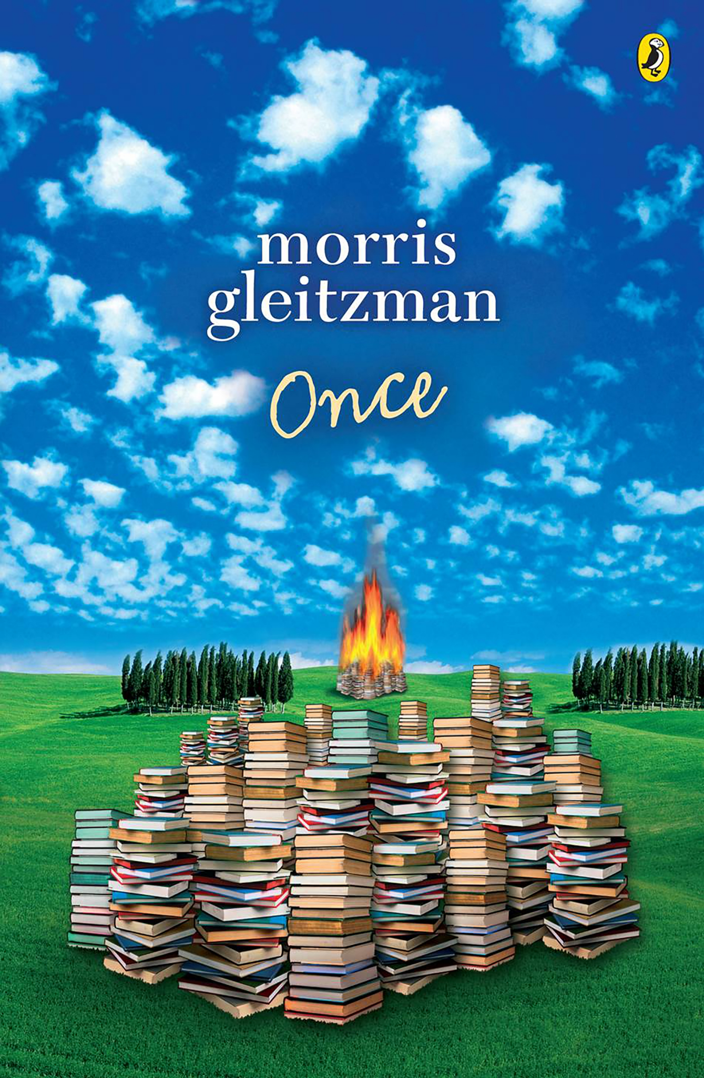
- Information Report
- Reading Fluency
- Building Vocabulary
- Building Background
Knowledge

SPELLING AND GRAMMAR

- Prefixes and Suffixes
- Greek Roots
- Clauses and Complex Sentences
- Subordinating Conjunctions
- Noun Groups

MATHS

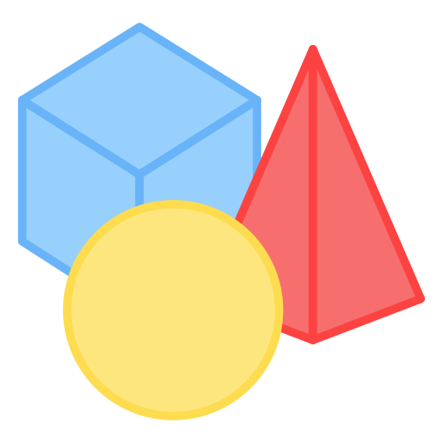
- Perimeter and Area
- Fractions
- 3D Objects
- Decimals
- Probability

INQUIRY

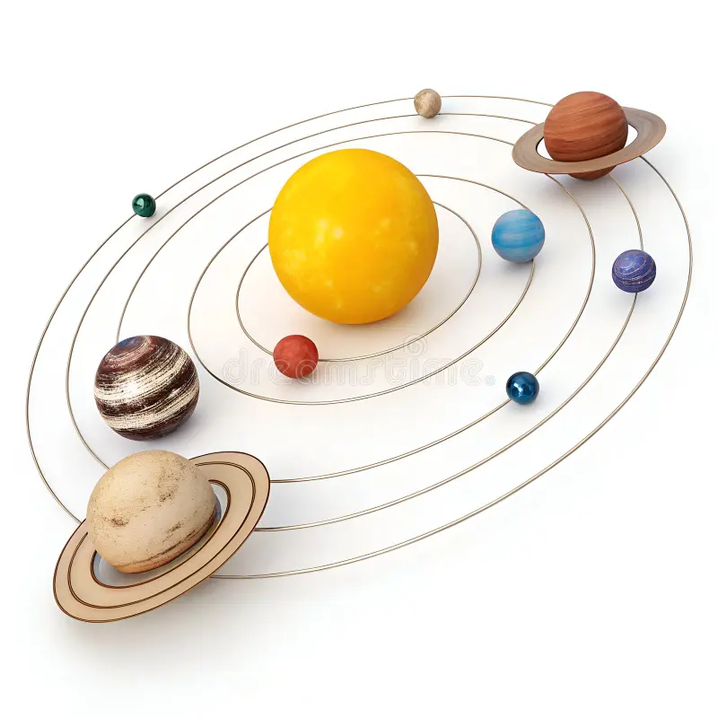
Unit: The Science of Energy:
From Circuits to the Cosmos.
How do invisible forces
and energy affect the
way our world works?

DIGITAL TECHNOLOGY

- Lego Education: Creating
Digital Solutions

WELLBEING

- Cultural Diversity
- Racism
- National Sorry Day
- Lead Well, Live Well - Growing Great Leaders (Year 5)
- Better Buddies (Year 6)
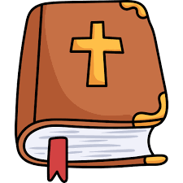
RELIGION

- The Year of Matthew
- Discipleship

ITALIAN

Earth Sciences

- 5 Senses
- The planets/space
- Seasons/ Weather
- Simple Cycles - animals and plants
- Simple sentence writing

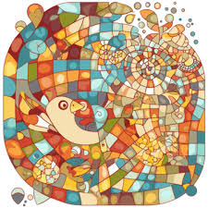
THE ARTS

- Mosasics

3D Art
- Clay
- Paper Mache

PHYSICAL EDUCATION

- Winter Interschool Sport
- Volleyball
- Manage emotions during
team play
- Contribute to group
activities

