

Year 3/4 – Term 2 Overview 2026

LITERACY
LISTENING AND SPEAKING
- Sharing and extending ideas and Information
- Using an expanded Vocabulary
- Presenting skills

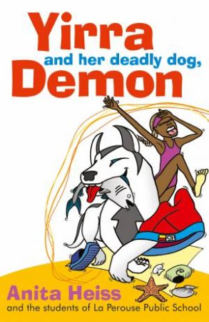
READING & WRITING
- Book Study - Yirra and her Deadly Dog
- Factual Recount
- Note taking
- Sentence Level Writing

Spelling & Grammar:
- Spelling rules
- Root words
- Tenses
- Homophones
- Connectives
- Synonyms

MATHS
- Number Fluency
- Counting
- Multiplication -
- Fractions
- Length & Area

- Data Representation
- 2D Shape
- Addition & Subtraction

INQUIRY
Unit: Matter Matters: How Things Change, Move and Interact!
WALT: How do different types of matter behave and change when forces and heat act on them?
- Classify solids, liquids, and gases
- Explore changes of state
- Understand the scientific process
- Learn that heat is transferable energy
- Use inquiry to explain natural forces
- Identify contact and non-contact forces
DIGITAL TECHNOLOGY
- Digital Systems
- Inputs vs Outputs

WELLBEING
- Positive Behaviour
- Respectful Relationship
- Cultural Diversity

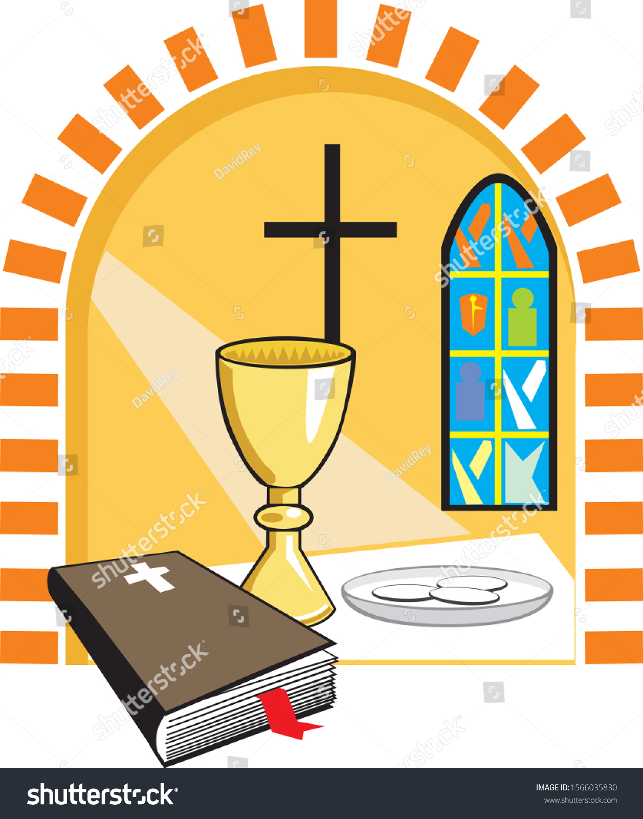
RELIGION
- Eucharist/Communion
- Feast of Corpus Christi
- Parts of Mass
- Setting up a Prayer Space

ITALIAN
- A day in the life of Me
- My needs vs My wants
- Language focus - directional and positional
- Colours
- Greetings and Introductions

THE ARTS
- Positive and negative space
- Sketching

PHYSICAL EDUCATION
- Roles in team activities
- Fair play and sportsmanship
- Volleyball
- Corn Hole

