Year Prep – Term 3 Overview 2021

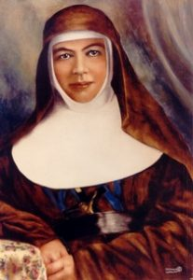
RELIGION
Mary MacKillop

God’s Great Family

Being Protected By God

ENGLISH
SPEAKING and LISTENING
- Following simple instructions
- Asking and answering questions
- Responding to texts
- Speaking in front of an audience
- Showing good listener skills

READING and VIEWING
- Learning letter names and sounds and blends
- Reading and recognising some of the 100 most used words
- Shared book experiences
- Predicting and making connections with a text
- Reading and recalling facts
- Using reading strategies to decode unknown words

WRITING
- Recounts
- Writing facts
- Letter writing
- Reflective writing
- Postcards

HANDWRITING
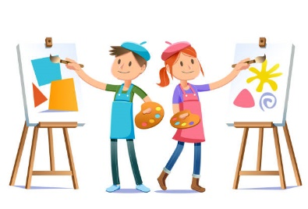
- Correct pencil grip
- Formation of letters

MATHS
NUMBER and ALGEBRA
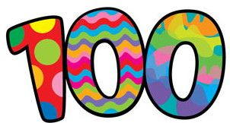
- 100 days of school
- Subtraction
- Sharing
- Money

MEASUREMENT AND GEOMETRY
- 3D Shape

DATA AND STATISTICS
- Graphing

INFORMATION AND COMMUNICATIONS TECHNOLOGY
- Cyber Safety

WELLBEING
- Respectful Relationships: Problem solving
and Positive Coping

INTEGRATED INQUIRY UNIT
We are one, we are many.
We are learning to understand that our community is made of many cultures.
- Prep Olympics Ceremony

VISUAL ARTS
French Impressionists
NGV visit
Painting and mixing colours

PHYSICAL EDUCATION
Fundamental Movement Skills

ITALIAN
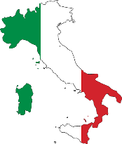
COMMUNITY
Italian Culture
Mapping Italy
Food
Traditions
Italian Stories
All about me

