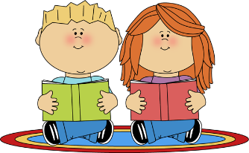
Reading
- using decoding strategies to decode words
- reading different types of texts independently
- reading poetry
- reading and note taking from non-fiction texts
- literal and inferential comprehension
Writing
- writing for different purposes and audiences
- Recounts
- Information reports
- Poems
- Narratives
- The writing process
- Knowledge of sounds to spell unfamiliar words
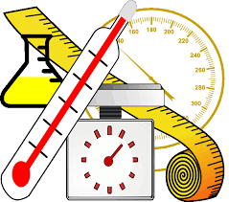
Mathematics
- Subtraction
- Links between addition and subtraction
- 2D and 3D shapes
- Patterns and transformation
- Measurement – Length, mass and capacity

Religious Education
- God’s Creation
- Love one another
Inquiry
- ‘We’re going on an ENVIRO hunt!’ How do living things rely on their environment to grow and thrive?
Wellbeing
- Emotions
- Friendships and solving problems
Italian
“Where on earth?”
- Habitats (farm, sea, desert and jungle) - animals, plants, colours
- Seasons and weather
- Descriptive language
Visual Arts
- Printing
Physical Education
- Athletics, fitness and gymnastics
Digital Technology
- Staying safe online

