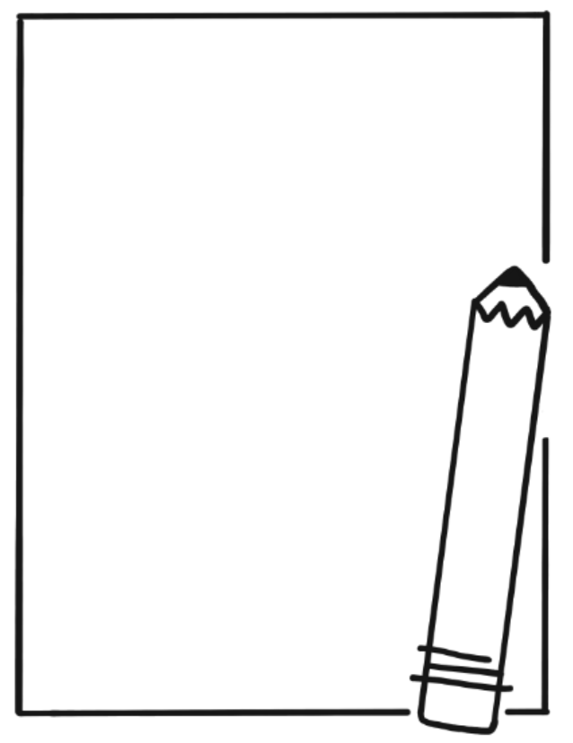
Year 1 and 2 Term 1 Overview

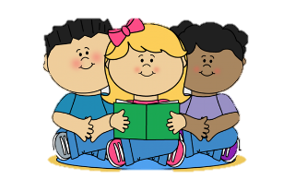
Reading
- Understanding the message of a story
- Using a variety of reading strategies to decode words
- Reading different types of texts independently
- Literal comprehension

Writing
- Writing for different purposes and audiences
- Recounts
- Narratives
- Procedural Texts
- The Writing Process
- Sentence Structure
- Knowledge of sounds to spell unfamiliar words

Mathematics
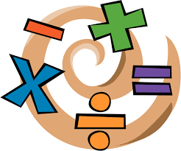
- Number – number sequences/knowledge, place value and addition
- Statistics and Probability – data and graphing

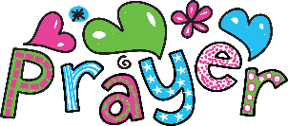
Religion
- Different types of Prayer
- Lent and Easter.

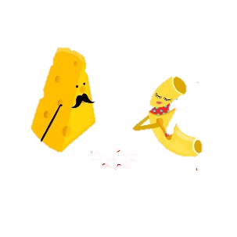
Inquiry
- We Belong Together!-
“What makes a happy and healthy Year 1/2 Community.”
We are learning to understand our physical, social and emotional wellbeing.

Italian
We Belong Together
- Feelings/Emotions
- Activities -sporting and social
- Staying safe - sun smart
- Healthy/Unhealthy

Visual Arts
- Collage

Physical Education
- Hand, eye coordination

