Year Prep – Term 1 Overview 2021

RELIGION
- Morning Prayer
- The Atrium
- Units:
The Good Shepherd
Lent

ENGLISH
SPEAKING and LISTENING
- Speaking and listening skills
- Following simple instructions
- Asking appropriate questions
- Responding to texts
READING and VIEWING
- Developing an understanding about print, i.e. read left to right, top to bottom, return sweep
- Matching pictures and text through book orientation
- Learning letter names and sounds
- Distinguishing between letters and words
- Recognising some of the 100 most used words
- Shared book experiences
- Predicting and making connections with a text

WRITING
- Recounting familiar events in pictorial form and attempting to write a related sentence
- Developing an understanding about writing, i.e. write left to right, top to bottom, return sweep and spacing
- Attempting to spell words by listening to the sounds they can hear
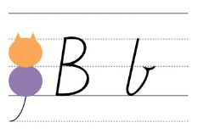
HANDWRITING
- Correct pencil grip
- Formation of letters

MATHS

NUMBER and ALGEBRA
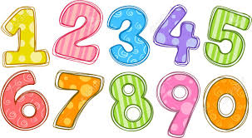
- Counting-place value, making collections
- Number games
- Recognising and writing numerals

MEASUREMENT AND GEOMETRY
- Sequence daily activities
- Days of the week
- Seasons/Months of the year
- 2D Shapes

STATISTICS AND PROBABILITY
- Data
- Pictographs

INFORMATION AND COMMUNICATIONS TECHNOLOGY
- Cyber-safety
- Appropriate use of devices
- Hector’s World

INTEGRATED INQUIRY UNIT
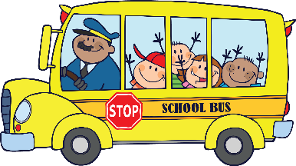
Ready, Set, School! Personal and Social Capability/Health:
We are learning about who I am and how to make friends.
- Social-Emotional Learning
- School Rules and routines
- Building confidence and positive risk-taking

PHYSICAL EDUCATION
- Hand, eye coordination
- Athletics

VISUAL ARTS
- Drawing – line, shape and colour

ITALIAN
ALL ABOUT ME
Introductions
- Ecco Pinocchio
- Likes/Dislikes
- Colours/Number
- Food (Brain Foods)

