Year 1/2 – Term 2 Overview 2020

RELIGION:
- Mary Mackillop
- God, Our Creator

ENGLISH:
LISTENING AND SPEAKING
- Speaking in front of an audience
- Giving constructive feedback to peers
- Forming Questions

READING
- Decoding unfamiliar language
- Recognising common blends, suffixes and digraphs/ trigraphs
- Literal Comprehension
- Main Idea
- Inferring Meaning
- Locating information in a text
- Reading for meaning
- Research Skills
- Note taking

WRITING
- Character Perspectives
- Rereading for editing purposes.
- Sentence Structure
- Editing and publishing
- Information Texts
- Narratives
- Knowledge of sound to spell words

HANDWRITING
- Appropriate size and sloping
- Letter formation
- Using dotted thirds appropriately

PEROSNAL AND SOCIAL CAPABILITY
- Working in groups
- Being an independent and organised learner

VISUAL ARTS
Mrs. Nathalie
- Color and shape

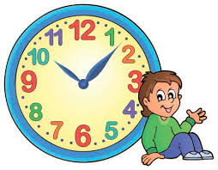
MATHS:
NUMBER
- Skip counting
- Place Value
- Multiplication

MEAUREMENT AND GEOMETRY
- Time
- Calendars, months and seasons

STATISTICS AND PROBABILITY
- Collecting and representing data
- Using data to create graphs

COMPUTERS
- Using Google Drive
- Responsible use of internet and search engines
- Using Google to publish and present work

INTEGRATED INQUIRY UNIT
We are Earth Scientists
We are learning to explain how observable changes on Earth impacts on our daily lives.

WELLBEING
- Emotional literacy
- Understanding and managing our emotions

PHYSICAL EDUCATION
- AFL
- Gymnastics

ITALIAN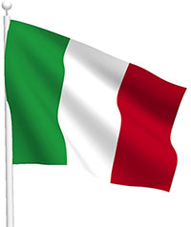
Signora Anderson
- Italy and her stories

