Year 3/4Term 1 2020

erm 3 O

verview – 2016

Religious Education
- Prayer
- Lent

English
Reading
- Comparing text genres
- Inferential and literal comprehension
- Letters
- Narratives
- Persuasive texts

Writing
- Spelling choices
- Editing
- Paragraphs
- Letters
- Narratives
- Persuasive texts
- Creating writing goals

Speaking and Listening
- Speaking in front of an audience
- Expressing feelings and opinions on topics and texts

The Arts
- Drawing Caricatures
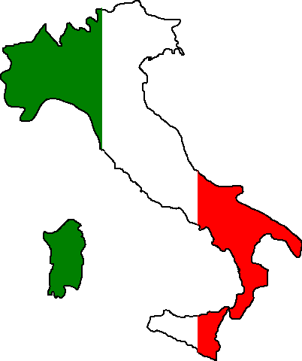
Italian
- Io/Me Pasqua
- All About Me
- Feelings
- Human Body

Mathematics

Number and Algebra
- Addition

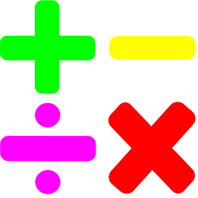
- Fractions
- Multiplication
- Number Patterns

Statistics and Probability
- Data and Graphs

Integrated Studies
Critical and Creative Thinking
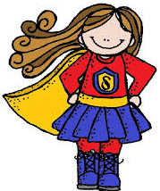
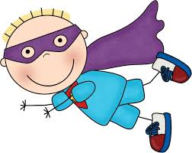
“Super Learners!”

We are learning how we can become better learners!

Wellbeing
- School rules
- Our rights and responsibilities
- Growth mindset
- Feelings
- Regulating emotions
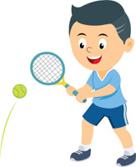
Physical Education
- Tennis
- Fitness
- Cross country

Technology
- Responsible use of internet and search engines
- Google Drive
- Sending emails

