Year Prep – Term 1 Overview 2020

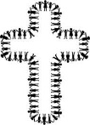
RELIGION
- Morning Prayer
- The Atrium
- Units:
The Good Shepherd
Lent

ENGLISH
SPEAKING and LISTENING
- Speaking and listening skills
- Following simple instructions
- Asking appropriate questions
- Responding to texts
READING and VIEWING
- Developing an understanding about print, i.e. read left to right, top to bottom, return sweep
- Matching pictures and text through book orientation
- Learning letter names and sounds
- Distinguishing between letters and words
- Recognising some of the 100 most used words
- Shared book experiences
- Predicting and making connections with a text

WRITING
- Recounting familiar events in pictorial form and attempting to write a related sentence
- Developing an understanding about writing, i.e. write left to right, top to bottom, return sweep and spacing
- Attempting to spell words by listening to the sounds they can hear
- Using correct punctuation (Capital Letters and Full Stops)
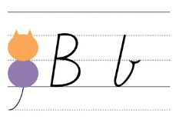
HANDWRITING
- Correct pencil grip
- Formation of letters

WELLBEING
- Social-Emotional Learning
- School Rules and routines
- Building confidence and positive risk-taking

MATHS

NUMBER and ALGEBRA
- Counting-place value, making collections
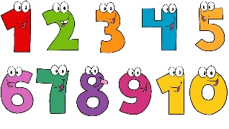
- Number games
- Recognising and writing numerals

MEASUREMENT AND GEOMETRY
- Sequence daily activities
- Days of the week
- Seasons/Months of the year
- 2D Shapes

STATISTICS AND PROBABILITY
- Grouping objects according to different attributes
- Pictographs

INFORMATION AND COMMUNICATIONS TECHNOLOGY
- Cyber-safety
- Appropriate use of devices

INTEGRATED INQUIRY UNIT
This is me! Let me shine!
Personal and Social Capability/Health:
We are learning to understand who we are.

PHYSICAL EDUCATION
- Fine and gross motor skills
- Tag Games

VISUAL ARTS
- Drawing me
- Using common shapes to make a person

ITALIAN
Pinocchio Pasqua
- Colours
- Greetings
- Numbers 1-10
- Greeting song

