Year 1/2 Term 4 2019

erm 3 O

verview – 2016

Religious Education
- Stories of God’s People
- Advent and Christmas

English
Reading
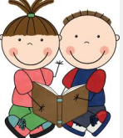
- Use reading strategies to read unfamiliar words
- Reading texts independently
- Literal and inferential comprehension
- Dreamtime stories, diagrams and narratives
- Comparing images

Writing
- Writing for different purposes and audiences
- Rereading for editing purposes
- Sentence structure
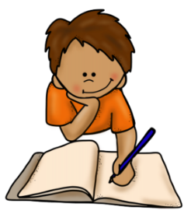
- Knowledge of sounds to spell unfamiliar words
- Synonyms and antonyms
- Using conjunctions

Speaking and Listening
- Interviewing and posing questions
- Speaking clearly and audibly in front of an audience
- Reading with expression

The Arts
- Origami

Italian
- Christmas
- Celebrations
- Greetings
- Italian Day

Mathematics
Number and Algebra
- Calendars, seasons and months
- Number patterns
- Solving number problems
Statistics and Probability
- Chance
Geometry
- Lengths, mass and capacity
- Calendars, seasons and months

Integrated Studies
History and Geography
“Step Back in Time”
We are learning to understand the changes in our community over time.

Wellbeing
- Experiencing different feelings (shy, worried, hurt, left out, stressed etc)
- Emotional triggers
- Self-regulation
- Managing anger
- Stress and relaxation
- Facing fears
Physical Education
- Soccer
- Kickball

