

**RELIGION** 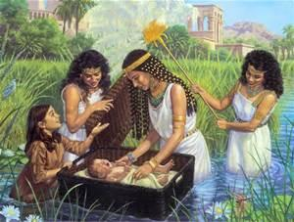

LEARNING ABOUT:

* God’s Great Family
* Being Protected By God

PRAYER ‘Hail Mary’

**ENGLISH**

LISTENING and SPEAKING

* Speaking audibly/role-playing
* Performing for an audience
* Listening and responding

READING

* Developing reading strategies 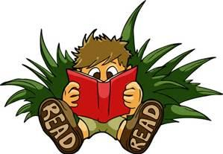
* 100 most used words recognition
* Reading big books through choral reading and shared book experiences
* Reading different types of genres
* Reading comprehension

WRITING

* Using a variety of writing strategies to spell
* Editing own work
* Compose simple texts
* Writing for an audience-postcards

*Handwriting*

* Correct pencil grip
* Correct starting point and formation for lower case letters
* Writing on lines



**WELLBEING**

* Friendly Schools
* Respectful Relationships



**MATHS**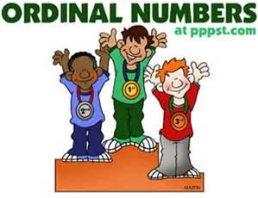

NUMBER

* Subtraction
* Money
* Ordinal

MEASUREMENT and GEOMETRY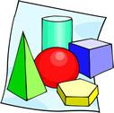

* 3D Shapes 

STATISTICS and PROBABILITY

* Collect information
* Use objects and drawings to organise simple data 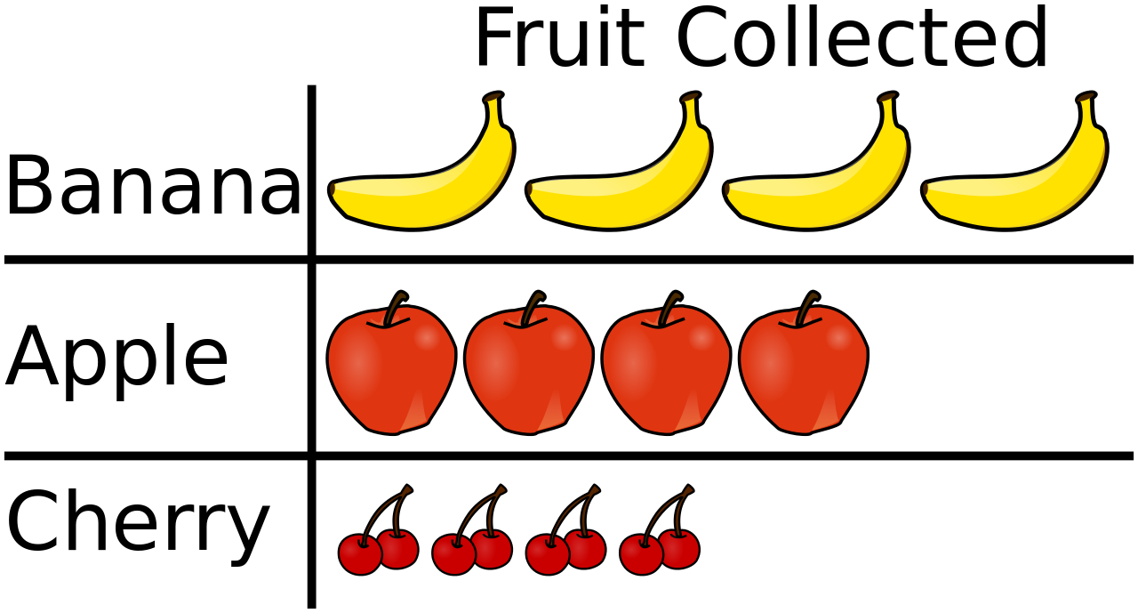

**INTEGRATED INQUIRY UNIT**

**Around the World We Go!!**

**We are learning to understand that Australia is made up of many cultures**





**PHYSICAL EDUCATION-Miss Brittney**

* AFL
* Gymnastics

**VISUAL ARTS – Miss Nathalie**

* Painting

**ITALIAN – Signora Anderson**

* Italian History

-Pinocchio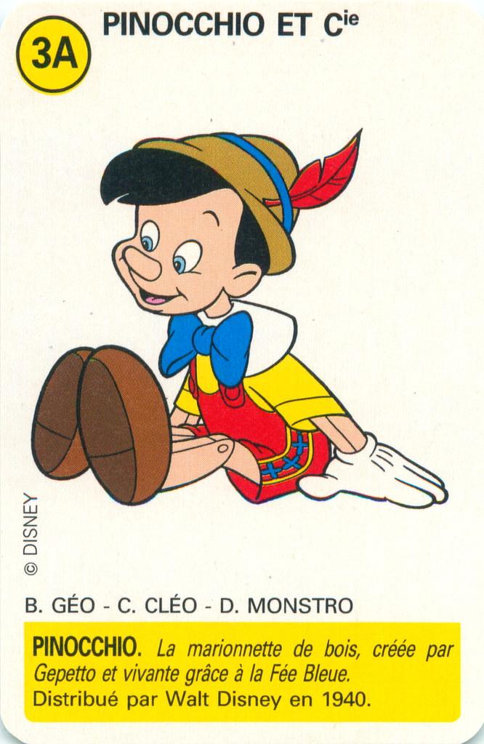

-Games and stories